**GitHub**



**Version Control Tool:-**

* In my org we are using GitHub as version control tool
* Version control tool helps to keep track of contributions of the team member towards one single project and maintain the code changes

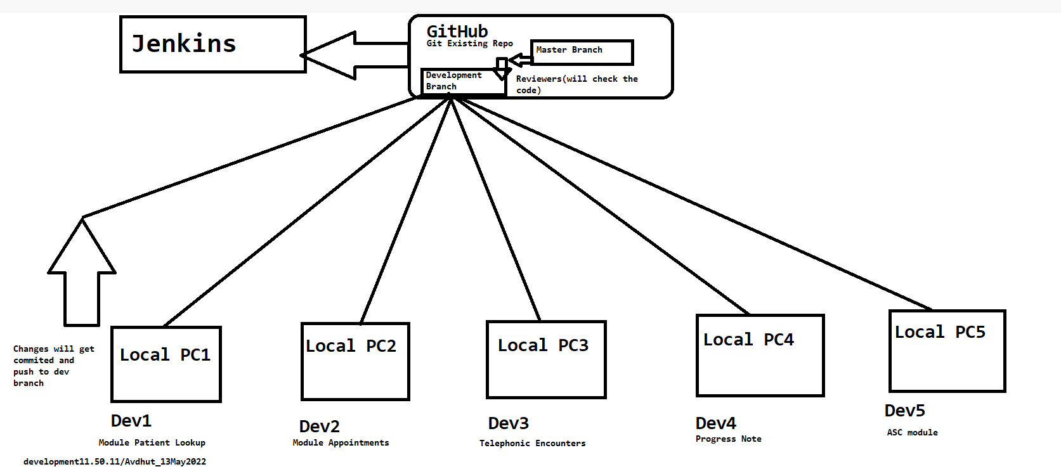

* It provides security towards underdeveloped or predevelop projects

Git Clone:-

It is use take copy of already existing project repository from branch of git hub

Git config –

git config is used to set configuration for git files example, set name , date and time

* git config –global

user.name

“avdhut”

Branches:-



  git conflict :-

git  handles branches merges automatically but sometime while working on same module, there might be an issue occurred related to conflict

What is Conflict?

* When two separate branches have changes to the same line in file
* Or A file is deleted in one branch but has been modified in the other branch

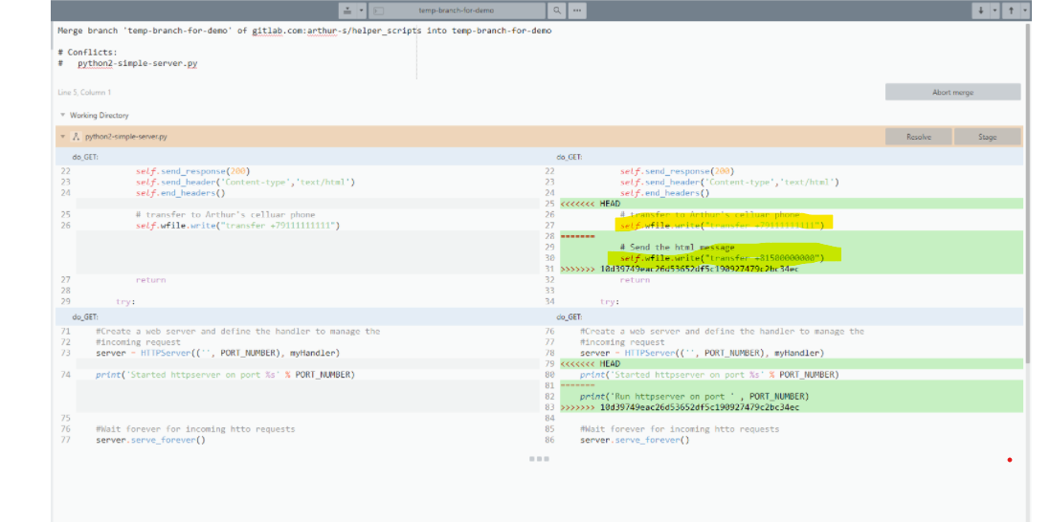

Pull request :-

This process is done when there is a need to put any dev changes into another branch

Branch:-

It is separate version of code

Push request:-

It is done when the target repo requests us to push our changes.

Git Commands:-

Git commands are used to handle git operations like

Switching between branch, push and pull changes, cloning of project, removing untracked files, also for configuration  etc.

Git commands:-

Question:

Tell me any 5 git commands that u are aware about?

git push

* Pushing allows you to move local branch to another repo which serves as a convent way to publish contribution

git pull

* It download a branch from remote repo

git fetch

* Downloads a branch from another repo will all commits and file but it will not download entire integrated version of that file.

git config

* Set configuration options

git checkout-

* Switching between the branches

git commit-

changes those are staged get commited.

git clone

* Take clone of main branch , project

git clean

* To clear untracked unwanted files

git merge

* To merge the branch with main branch

git remote

* To push local repo to remote repository

Steps to clone and commit and push

* Get link of existing repo on github
* Eclipse search Git Repositories
* Clone repositories and add clone into view option
* Paste the link and enter user name and PAT
* Click on next , >>> finish
* Right click on  project >>select repository from dropdown>> share project>> add credentials>> finish.

Push the changes:-

* Right click on project

* Commit

* Staged the changes

* Add msg

* Commit and push